**[IS 603 Decision Making Support Systems](https://blackboard.umbc.edu/webapps/blackboard/execute/courseMain?course_id=_53232_1" \o "IS 603 Decision Making Support Systems (01.6397) SP2020)**

[**Capstone Decision Paper**](https://blackboard.umbc.edu/webapps/assignment/uploadAssignment?content_id=_3671904_1&course_id=_50634_1&group_id=&mode=cpview)

**COVID’19 DATA ANALYSIS**

Submitted to

**John Hebler**

By

**Chitti Babu Sugguna**

**Devesh Moolchand Ajbani**

**Mahendra Amarnath Panuganti**

**Pranvat Singh**

**Simran Kaukab Shaik**

**Vaishak Annegowda**

**M.S. Information Systems**



Department of Information Systems

University of Maryland Baltimore County

Baltimore, USA

**Table of Content**

**1.EXECUTIVE SUMMARY** 3

**2.OPPORTUNITY/BACKGROUND** 4

**3.LITERATURE REVIEW:** 5

**4**.**DECISION ASSUMPTIONS** 5

**5. DECISION FACTORS EXPLANATION AND JUSTIFICATION** 6

**6.DECISION METHOD/APPROACH** 7

**7**. **RISK FACTORS** 11

**8**. **DECISION CONCLUSION WITH SUPPORTING JUSTIFICATION** 12

**10**. **REFERENCES** 13

# **1.EXECUTIVE SUMMARY**

Numerous countries around the world have been placed in a vulnerable situation due to the ongoing spread of the latest coronavirus 2019, called COVID-19, by the World Health Organization. The implications for almost every nation of the world of the COVID-19 epidemic, which was previously observed only by Chinese citizens, have now become a matter of serious concern. In tandem with the fear of overburdened health care facilities, the shortage of funding for the COVID- 19 epidemic has caused a lot of these countries to lock up in part or in whole. COVID-19 changed life today for everybody. At least 316,000,000 people were told to sit at home in 42 countries to contain the pandemic. Companies are subject to significant changes in this respect. Many businesses provided online office services.

There is an unprecedented rise in the number of laboratory-confirmed cases worldwide, with more than 3 million confirmed cases officially happening on 30 April 2020. Furthermore, after the outbreak of the COVID-19, various misleading stories, rumors and unsolicited concerns regarding coronavirus have been circulated daily. In reaction to these actions, a thorough analysis of all the main aspects of the COVID-19 pandemic is supported by numerous credible sources. This research highlights the impact on the global economy in combination with the immediate health implications linked with the emergence of COVID-19. we investigate the use of technology such as the IoT (Internet of Things), UAVs, blockchain, AI, and 5 G, among others, to reduce the effects of the COVI D-19 epidemic. The 2019 coronavirus disease (COVID-19) was caused by a serious acute coronavirus 2 disease (SARS-CoV-2) infection. The cornerstone for crisis and pandemic management is an initiative to combat the COVID-19 spread which provides fast and careful molecular diagnoses and serology analysis.

It is mainly thought to spread by person, mainly through respiratory droplets produced by the cough or sneezing of an infected person. Such droplets may land in people's mouths or nose that lie or can be inhaled into their lungs. Dissemination is most likely if individuals have direct contact (about 6 feet) with each other. You will get COVID-19 by rubbing a surface or object with the virus and then rubbing your own lips, nose or maybe eyes. The key reason the virus spreads is not called that, but we still know more about it.

The COVID-19 virus spreads between people very quickly and sustainably. The current COVID-19 pandemic indicates that this virus is more effective than influenza but not as powerful as extremely infectious measles.

# **2.OPPORTUNITY/BACKGROUND**

Health informatics had never played a greater role in public health than during the COVID-19 pandemic. While the health IT industry is certainly challenged because of the overall disruption of the healthcare system, the pandemic undoubtedly underlines the opportunity and importance of health information technology, such as telehealth, remote patient monitoring, patient engagement, AI-based drug development, precision medicine, and support for clinical decision taking, but nowhere more pressing than bioinformatics, clinical monitoring, and predictive modelling.

Coronavirus is a positive, enveloped, single-strand RNA virus. This belongs as the name to the Ortho Coronaviridae subfamily with the distinctive "crown-like" spikes on their surfaces. It also falls into the beta-coronavirus class along with SARS-CoV, bat SARS-like CoV and others. COVID-19 (caused by 2019-nCoV infection) as a notifiable fifth category communicable disease in Taiwan. The genus beta-coronavirus can be divided into many subgroups. Sarbecovirus belongs to the 2019-nCoV, SARS-CoV and bat SARS-like CoV while Merbecovirus belongs to the MERS-CoV. SARS-CoV, MERS-CoV, and 2019-nCoV all cause human disease, but each subgroup may have mildly different biological and virulence characteristics. Most people infected with the COVID-19 virus will develop mild to moderate respiratory disease and recover without any special treatment being needed. Older people and those with underlying health conditions such as cardiovascular disease, diabetes, chronic respiratory disease and cancer are more likely to experience serious illness. Being well informed about the COVID-19 virus, the disease it causes and how its spread is the best way to avoid and slow down transmission. Protect yourself and others from contamination by washing your hands or regularly using a rub based on alcohol, and not touching your skin.

The current emphasis on the transmission of COVID-19 infection worldwide may possibly divert public attention from the psychosocial effects of the epidemic in the individuals affected and in the general public. The emerging mental health problems associated with this global event may become long-lasting health problems, isolation and stigma. Global health measures should be employed to address psychosocial stressors, particularly in relation to the general population's use of isolation / quarantine, fear and vulnerability.

# **3.LITERATURE REVIEW:**

In this research paper author review about a previous unidentified coronavirus, currently referred to as the 2019 novel coronavirus, originated from Wuhan, China in late December 2019, resulting in a formidable outbreak in several Chinese cities and spreading globally. The illness is formally named Coronavirus Disease-2019. It is also identified by the Taiwan CDC, the Ministry of Health, as Extreme Pneumonia with Novel Pathogens on January 15, 2019 and is a notifiable, fifth category communicable disease. COVID-19 is a potential zoonotic disease with mortality rates low to moderate. Person-to-person transmission may occur via droplet or contact transmission, and if there is a lack of stringent infection control or if there is no adequate personal protective equipment available, first-line healthcare workers could be placed at risk. (Yi-Chi,2020).

The author here talks about, at a time when it can seem like our lives and livelihoods are somehow tied to what gets spit out of these COVID-19 models, it is a good time to learn a bit about what the models are made up of, and what they can and can’t do. Models can be enormously useful when synthesizing evidence and scientific knowledge in the context of an epidemic. The COVID-19 pandemic is a complicated phenomenon, and it is almost difficult to make informed decisions in such a dynamic environment without the aid models being able to provide. (Elizabeth,2020).

The author in this article explains about how the ongoing outbreak and spread across the globe of COVID-19 coronavirus infection among humans in Wuhan (China) has a significant effect on global health and mental health. Despite all the tools used to combat the spread of the virus, there is a need for additional global approaches to tackle the associated mental health issues. (Torales,2020)

In this journal the author talks about how they draw on various reliable sources to present a detailed review of all the major aspects associated with the COVID-19 pandemic. In addition to the direct health implications associated with the outbreak of COVID-19, this study highlights its impact on the global economy. We explore the use of technologies such as the Internet of Things (IoT), Unmanned Aerial Vehicles (UAVs), blockchain, Artificial Intelligence (AI), and 5 G to help reduce the effect of COVID-19 outbreak, among others. (Chamola,2020)

**4**.**DECISION ASSUMPTIONS**

The COVID-19 decision-making models, such as directing health care resources to certain areas or identifying how long social distancing policies may need to be in place.

The irony of many COVID-19 modelling uses is that a key aim in building and disseminating the model in some cases, particularly for forecasting, is to evoke behavioral change at a person or system-level — e.g., to reinforce the need for physical distancing.

One of the complexities of COVID-19 modelling is the multitude of variables involved: the nature of infectious diseases, social and behavioral variables such as how often people communicate economic factors such as jobs and safety net policies and more.

A trade-off in complex system modelling is that more complex models need either more systemic assumptions (e.g., how the disease spreads) or more data. Consideration of the validity of both pieces is important: how much is known about the spread of the disease and other systemic assumptions, and whether the inputs of the data are secure.

# **5. DECISION FACTORS EXPLANATION AND JUSTIFICATION**

COVID-19 can affect anyone and symptoms can vary from mild to very severe. With some other respiratory virus-caused illnesses (such as influenza), some individuals may be more likely to experience serious illness than others because they have characteristics or medical conditions that raise their risk. Commonly these are called "risk factors."

These are generally referred to as "risk factors." Examples include age 65 or older or severe underlying medical conditions. CDC carries out disease monitoring and field surveys to help understand why certain individuals are more likely to develop serious COVID-19 disease. It is one of the top goals for battling COVID-19 in CDC 's policy. What we learn from these efforts will provide vital information to help CDC scientists and other officials in public health take decisions to protect our most vulnerable populations. The CDC performs these activities in cooperation with departments of state, local, and territorial health; public health, medical, and clinical laboratories; vital statistics offices; health care providers; emergency departments; and partners to the academic and private sectors.

It is important to learn about risk factors for severe COVID-19 illness because it can help you:

* Take extra care to prevent exposure to the COVID-19 virus.
* When you are sick with COVID-19, better understand how a medical condition could affect your health.
* Anticipate any medical treatment you may need if you become ill.
* Reduce the risk of severe COVID-19 disease by controlling any problems you may have which are risk factors.

Supervising isolation and quarantine gradually became, under the Constitution, predominantly a state power. It wasn't until the nineteenth century that the federal government had first engaged in quarantine control. At the time, yellow fever outbreaks entered the US through southern ports, and Northern states sought to remain out of the scourge by violently shutting their borders in "shotgun quarantines." Price shared findings from its quarantine research — in which Congress interfered.

# **6.DECISION METHOD/APPROACH**

We started the analysis by compiling available datasets and cleansing the data by removing redundant information from the data world Website.

**Data Collection:**

All the data for our study is collected from the data world. The data has all statistics for COVID’19. The data includes a number of positive cases, location, deaths, countries and date. The data available on the website is in form month wise cases in csv. This data has been loaded in the tableau and visualizations are performed.

**Data Pre-processing:**

The data available from the website had null values, redundant data like special characters. We removed all the unnecessary data and a data cleansing activity was performed for better visualization and valued results. The final data is cleaned with all the Unicode errors also removed.

**Data Analysis:**

Data analysis is performed using tableau. Tableau is a very powerful visualization tool and it is also used for predictions. Moreover, in tableau you can visualize and present the data in a unique way. We have also forecasted the data and predicted a number of positive cases in future with the help of various functions in tableau.

**Predictions and results:**

We have presented our results and found that the US is the most affected country during this COVID’19 followed by Spain, Italy and France. The number of positive cases in Europe and North America are very high, whereas cases in Australia are very low with just cases over 6000 all over the country. The other nations affected are Brazil, UK, Germany and Iran. The cases have stopped in China and Taiwan. A recent increase of cases in Russia is also seen.

**Visualization:**

We analyzed this COVID’19 data and found out some interesting results. Some of these results are shown below:

The below visualization shows the map distribution of cases all over the world. It describes the total number of positive cases all around the world in a map format.

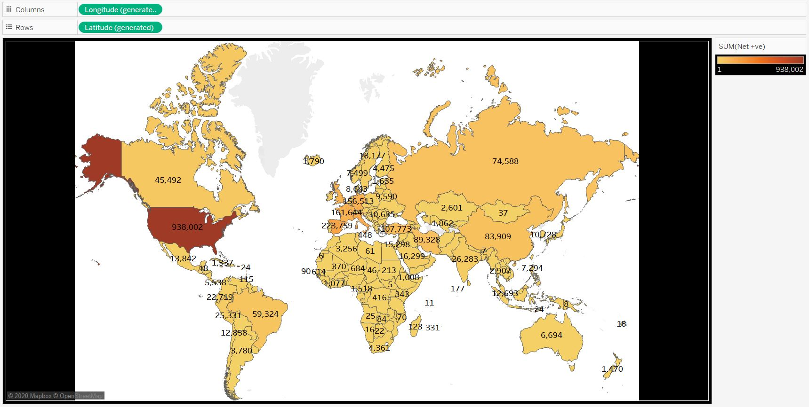

**Map Distribution**

**Fig 1**

The figure 2 shows the global distribution of all the countries with positive and death cases. It is clearly seen that US has 4 times more cases than the second place Spain.

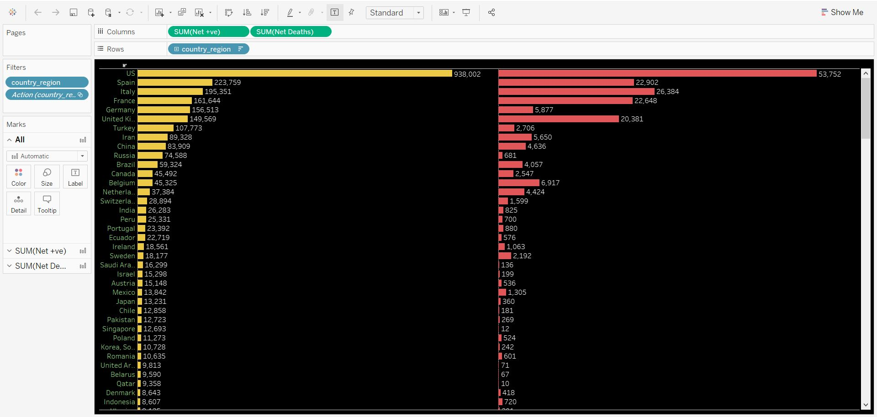**Global Analysis**

**Fig 2**

Figure 3 shows the actual and the estimates of positive corona cases and the graph forecasts more than 5 million cases by 25th March.

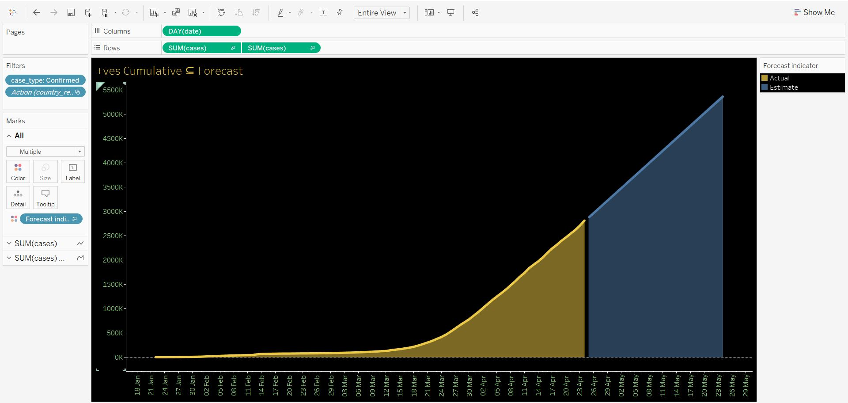

**Number of Positive cases cumulative estimate**

**Fig 3**

Figure 4 shows the cumulative death cases for actual and estimates approximately 4 lakh cases by 25th March.

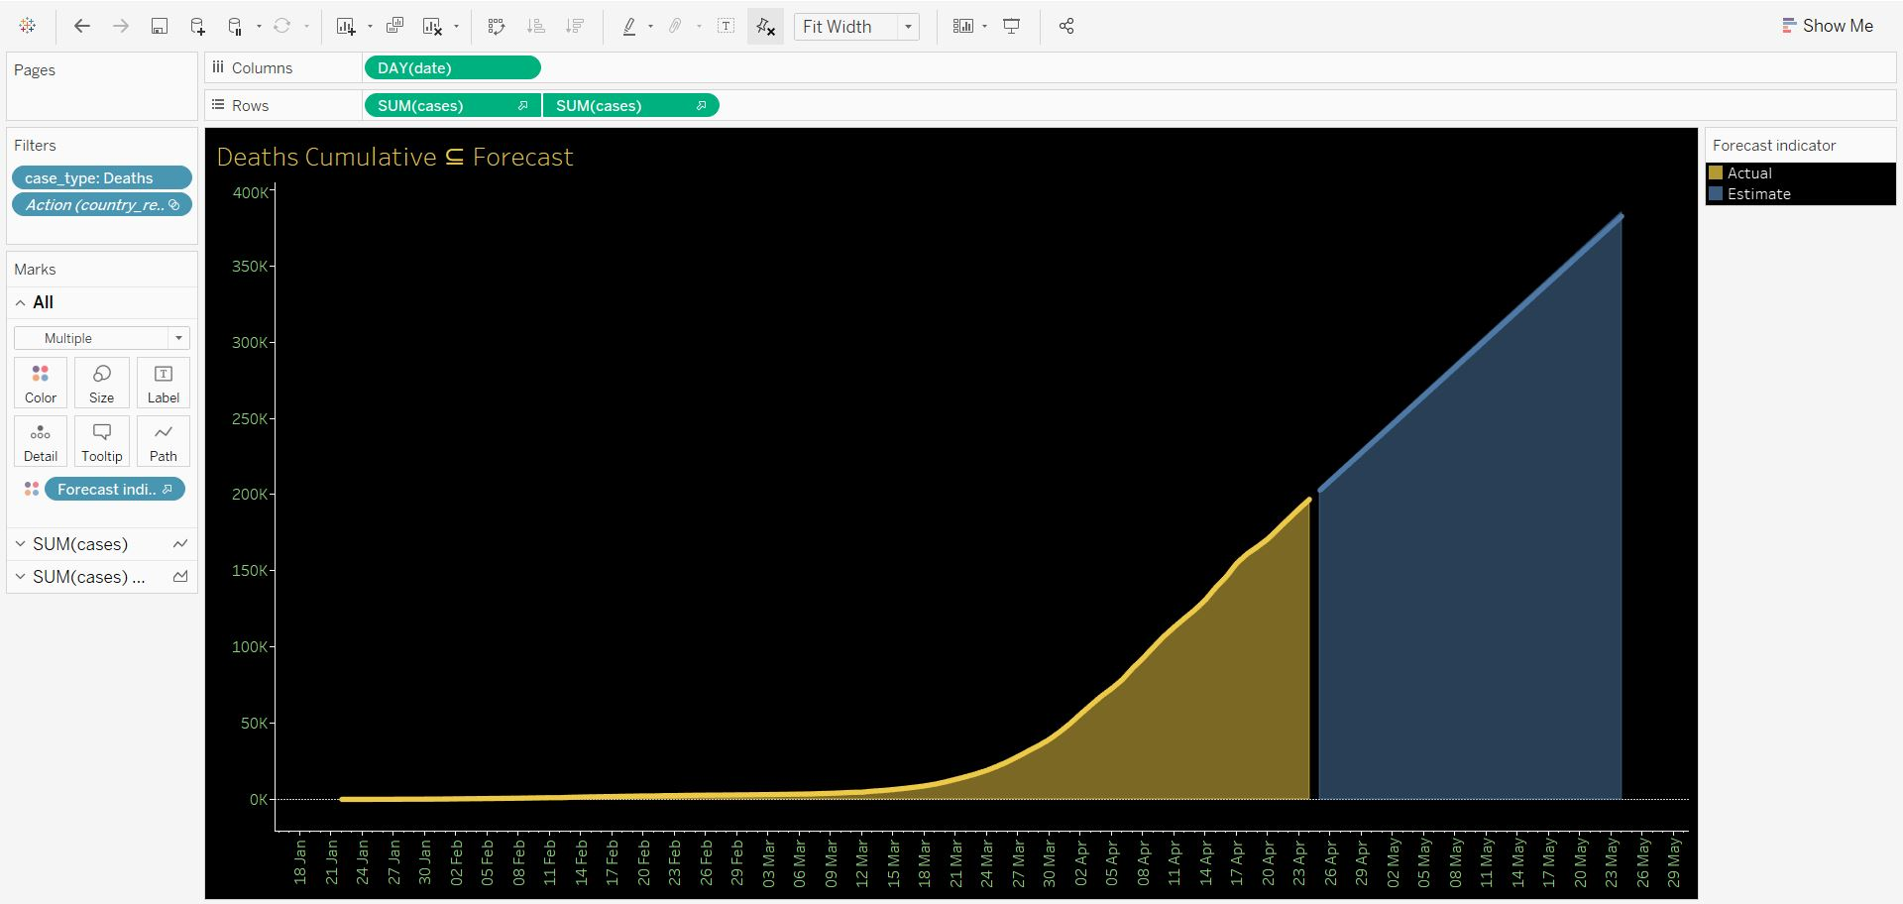

**Number of death cases cumulative estimate**

**Fig 4**

Figure 5 is the dashboard of the analysis done.

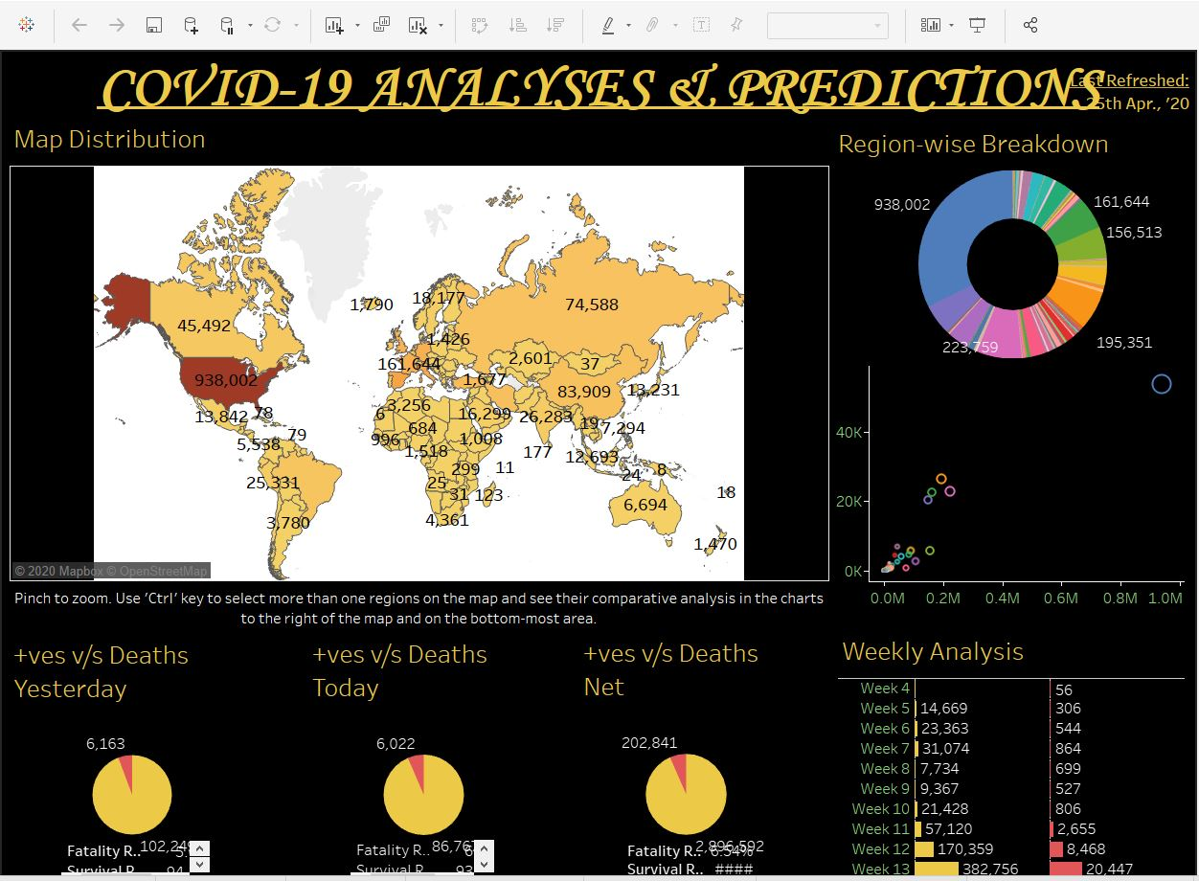

**Dashboard**

**Fig 5**

Figure 6 explains the ranking of universities by country.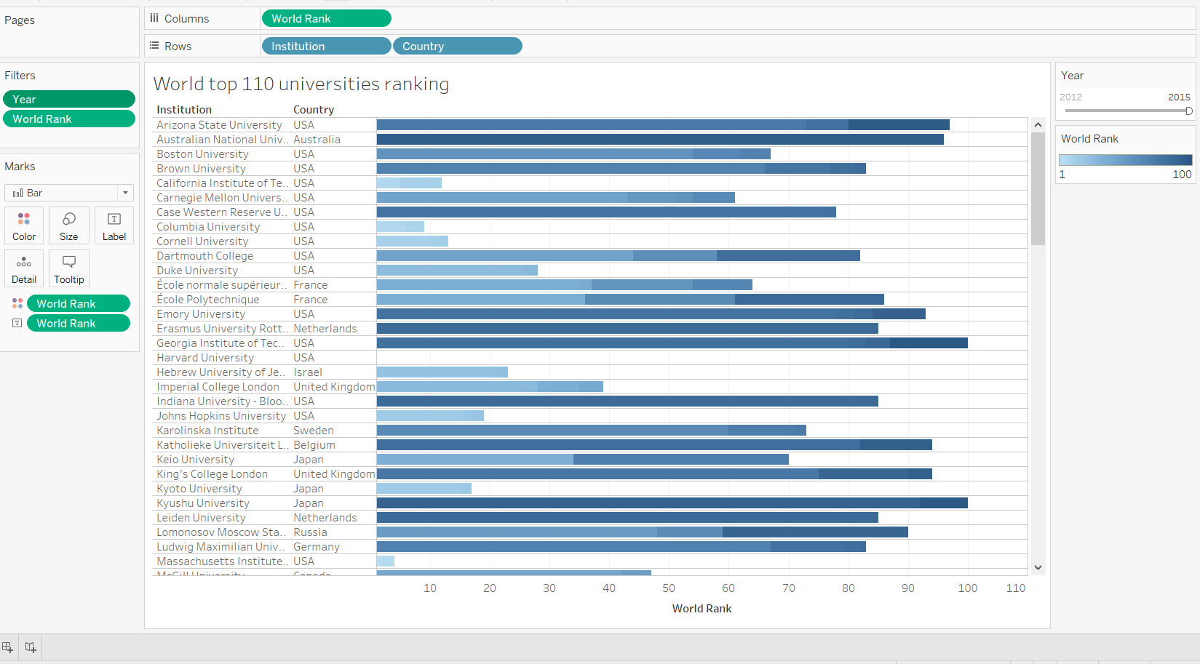

**Ranking of world's top ranked 110 universities**

**Fig 6**

# **7**. **RISK FACTORS**

A risk factor is a variable associated with increased risk of spread of disease and infection that precedes an outcome and is associated with the subsequent likelihood of that outcome. Identifying risk factors for spread of disease is fundamental to a risk-focused approach to designing and targeting prevention programs. The presence of a single risk factor does not guarantee the spread of virus world-wide. The main risk domain for spread of virus are the individual, family, peer and community. This depends on one or more perspectives. Awareness program among the community members would definitely work as the greatest number of people are getting infected in the closed community is the number of positive cases is increasing exponentially. Age, ethnicity, some medical condition, certain occupation, use of certain medications, poverty and crowding are the potential risk factors that have been identified.

The health bulletin on COVID 19 is updated daily on the government website. One can easily make use of the available data and plan their activities by looking at the number cases reported in the location. An awareness camp would help to further reduce the spread of virus.

# **8**. **DECISION CONCLUSION WITH SUPPORTING JUSTIFICATION**

To get the insight of the situation we analyzed the data using Tableau and Microsoft excel while discussing the spread of virus patterns happening around the world. After analyzing it can be decided that the spread of the virus is not reduced, so the government needs to take some specific action to control the outbreak of the virus. The public should adhere to the rule for wearing facial masks and maintaining social distance. The current focus on the transmission of COVID-19 infection all over the world may probably distract public attention from psychosocial consequences of the outbreak in the affected individuals and in the general population. The emerging mental health issues related to this global event may evolve into long-lasting health problems, isolation and stigma. Decisions should be made on closely monitoring and controlling information from the media and social network community.

**9. LIMITATIONS:**

* The uncertain increase in the number of COVID cases still after the situation is under strict control is subject to further extensive research still pose a limitation even though major reasons of pandemic outbreak are known.
* Progress on the life insurance carriers in the present and future days are full of questions like how to move forward even though they provide insurance coverage to the new and existing customers due to the pandemic.
* Undetermined change in lock down period as a reason for self-quarantine and prevention to avoid spread across country or state lines.
* Limitations on antibody testing for COVID have been put on people who recovered as the test goes unnoticed for active infection within a person's body.
* Few locations across the globe could not be inferred for any positive or negative tests of COVID as per map distribution.

# **10. REFERENCES**

1. Microbiology, aD. of. (n.d.). The outbreak of COVID-19: An overview: Journal of the Chinese Medical Association. Retrieved from <https://journals.lww.com/jcma/Fulltext/2020/03000/The_outbreak_of_COVID_19__An_overview.3.aspx>
2. Herndon, J., & JH Bloomberg School of Public Health. (2020, May 12). Articles. Retrieved from <https://www.jhsph.edu/covid-19/articles/>
3. COVID-19 and the Constitution - Key Takeaways. (n.d.). Retrieved from <https://www.constitutioncenter.org/interactive-constitution/blog/covid-19-and-the-constitution-key-takeaways>
4. Chamola, V., Hassija, V., Gupta, V., & Guizani, M. (2020). A Comprehensive Review of the COVID-19 Pandemic and the Role of IoT, Drones, AI, Blockchain and 5G in Managing its Impact. *IEEE Access*, 1–1. doi: 10.1109/access.2020.2992341
5. Kim, R. Y. (2020). The Impact of COVID-19 on Consumers: Preparing for Digital Sales. *IEEE Engineering Management Review*, 1–1. doi: 10.1109/emr.2020.2990115
6. Zhang, J., Gharizadeh, B., Lu, D., Yue, J., Yu, M., Liu, Y., & Zhou, M. (2020). Navigating the Pandemic Response Life Cycle: Molecular Diagnostics and Immunoassays in the Context of COVID-19 Management. *IEEE Reviews in Biomedical Engineering*, 1–1. doi: 10.1109/rbme.2020.2991444